# Design and Control of Prosthetic Arm Using Electromyography (EMG)

**

*By*

Zain ul Abideen

CUI/FA21-BCE-009/ATD

Aashir Ali Khan

CUI/FA21-BCE-011/ATD

Muhammad Rehan

CUI/FA21-BCE-002/ATD

BS Thesis

#### In

Computer Engineering

COMSATS University Islamabad Abbottabad Campus-Pakistan

Spring 2025



## COMSATS University Islamabad-Abbottabad Campus

# Design and Control of Prosthetic Arm Using Electromyography (EMG)

#### A Thesis Presented to

COMSATS University Islamabad-Abbottabad Campus

#### In partial fulfillment

Of the requirement for the degree of

BS Computer Engineering

By

Zain ul Abideen

CUI/FA21-BCE-009/ATD

Aahsir Ali Khan

CUI/FA21-BCE-011/ATD

Muhammad Rehan

CUI/FA21-BCE-002/ATD

Spring 2025

Design and Control of Prosthetic Arm using Electromyography (EMG)

A Undergraduate Thesis submitted to Electrical and Computer Engineering Department as partial fulfillment of the requirement for the award Degree of Bachelor of Science in Computer Engineering.

|  |  |
| --- | --- |
| Name | Registration Number |
| Zain ul abideen | CUI/FA21-BCE-009/ATD |
| Aashir Ali Khan | CUI/FA21-BCE-011/ATD |
| Muhammad Rehan | CUI/FA21-BCE-002/ATD |

## Supervisor

#### Dr. Zulfiqar Khattak

Associate Professor, Department of Electrical and Computer Engineering

#### Abbottabad Campus

COMSATS University Islamabad (CUI),

Abbottabad Campus

**Co-Supervisor**

Dr. Jamil Ahmad

Assistant Professor, Electrical and Computer Engineering Abbottabad Campus

COMSATS University Islamabad (CUI) Abbottabad Campus

July 2025

Final Approval

#### This thesis titled

Design and control of Prosthetic Arm using Electromyography (EMG)

By

*Zain ul abideen CUI/FA21-BCE009/ATD*

*Aashir Ali Khan CUI/FA21-BCE011/ATD*

*Muhammad Rehan*

*CUI/FA21-BCE-002/ATD*

Has been approved

For the COMSATS University Islamabad, Abbottabad Campus

Supervisor: _______________

Dr. Zulfiqar Kattak, Associate Professor

Department of Electrical and Computer Engineering,CUI, Abbottabad Campus

Co-Supervisor: ________________

Dr. Jamil Ahmad, Assistant Professor

Department of Electrical and Computer Engineering Engineering CUI, Abbottabad Campus

HOD: ____________________

Dr. Zahid Jahangiri, Associate Professor

Department of Electrical and Computer Engineering, CUI, Abbotabad Campus

**Declaration**

We Zain ul Abideen **CUI/FA21-BCE-009/ATD,** Aashir Ali Khan **CUI/FA21-BCE-011/ATD and** Muhammad Rehan **CUI/FA21-BCE-002/ATD**. hereby declare that I have produced the work presented in this thesis, during the scheduled period of study. I also declare that I have not taken any material from any source except referred to wherever due that amount of plagiarism is within acceptable range. If a violation of HEC rules on research has occurred in this thesis, I shall be liable to punishable action under the plagiarism rules of the HEC.

|  |  |
| --- | --- |
| Date: | Signature of the student: |
|  | Zain ul abideen |
|  | CUI/FA21-BCE-009/ATD  Aashir Ali Khan  CUI/FA21-BCE-011/ATD  _____________________  Muhammad Rehan  CUI/FA21-BCE-002/ATD |

# Certificate

It is certified that Zain ul Abideen **CUI/FA21-BCE-009/ATD ,** Aashir Ali Khan **CUI/FA21-BCE-011/ATD** and Muhammad Rehan **CUI/FA21-BCE-002/ATD** has carried out all the work related to this thesis under my supervision at the Department of Electrical and Computer Engineering, COMSATS University Islamabad, Abbottabad campus and the work fulfills the requirement for award of BS degree.

Date:

Supervisor: _________________________

Dr. Zulfiqar Khattak, Associate Professor

Department of Electrical and

Computer Engineering

Head of Department:

Dr. Irfan Ullah, Associate Professor

Department of Electrical and Computer Engineerin

**DEDICATION**

We humbly dedicate this study, first and foremost, to Allah, the Most Gracious, for granting us the strength, health, and wisdom to complete this work. We extend our heartfelt gratitude to our beloved parents and families for their unwavering trust and support.

To our institution, COMSATS University Islamabad, Abbottabad Campus, we offer our sincere thanks for providing us with the platform to learn and grow. Lastly, we dedicate this work to our esteemed supervisor and co-supervisor, whose invaluable guidance, leadership, and mentorship have been instrumental throughout this journey.

You have been our mentors, our cheerleaders, and our confidants, providing unwavering support through every triumph and setback. Your boundless patience, words of wisdom, and endless sacrifices have shaped us into the individuals we are today. You have given us wings to soar and the confidence to take on the world.

In the late nights and early mornings, while we toiled away at our projects, you were there, providing nourishment for both our bodies and souls. You created a haven of warmth and love, a sanctuary where we could find solace and rejuvenation amidst the challenges we faced. Your unwavering belief in our abilities never wavered, even when doubts clouded our minds.

It is with immense gratitude and pride that we dedicate this thesis to you, our beloved parents. Your unwavering love and support have been the cornerstone of our achievements, and this work stands as a testament to the values you have instilled within us. We are eternally grateful for your sacrifices, your guidance, and the love that has propelled us forward.

May this dedication serve as a small token of our appreciation, a mere reflection of the infinite debt of gratitude we owe you. As we embark on new horizons, we carry with us the lessons you have taught us, the values you have nurtured, and the strength you have bestowed upon us.

### 

### ACKNOWLEDGEMENTS

We sincerely express our profound gratitude to our distinguished supervisor, Dr. Zulfiqar Khattak, for his invaluable feedback, thoughtful suggestions, and dedicated involvement, which significantly contributed to refining the quality of our work. We also wish to acknowledge the immense support and guidance of our co-supervisor, Dr Jameel Ahmed, their consistent assistance and encouragement were instrumental in the successful completion of this bachelor's thesis. Their expertise and insightful guidance have greatly enriched our understanding of the subject and elevated the standard of our research. The knowledge and mentorship they generously provided have been crucial to our academic accomplishments and fostered a highly productive learning environment.

##### Zain ul Abideen CUI/FA21-BCE-009/ATD

**Aashir Ali Khan CUI/FA21-BCE-0011/ATD**

**Muhammad Rehan CUI/FA21-BCE-002/ATD**

**ABSTRACT**

Design and Control of Prosthetic Arm using Electromyography (EMG)

A huge fraction of population suffering from some form of amputation and automated prosthetics are very expensive. The mechanical prosthetics that are currently being used in the rehabilitation industry are bulky and a fatigue for the amputees to use which is the core reason they are not used in long runs. Belt harness prosthetics are typically attached to the body using a belt system, which places a significant load on the waist and hip area. The weight of the prosthetic limbs, along with any additional components, can lead to muscle fatigue and strain over time, especially if the user needs to wear the prosthetics for extended periods.

The Electromyography (EMG)-based control of prosthetic arms represents a vital and growing area of research within biomedical signal processing, aimed at enhancing the functionality and accessibility of prosthetic devices. This project focuses on utilizing EMG signals to design and control a prosthetic arm capable of replicating human limb movements. The process begins with acquiring EMG signals from human subjects as they perform various muscle activities. These signals will be processed to extract key features, which will then be fed into a classifier to train it for recognizing specific muscle actions. After training, new EMG signals will be passed to the classifier, enabling the system to identify and execute the corresponding prosthetic arm movements. This project involves evaluating various features and classification techniques to determine the most effective solutions. It also includes optimizing and implementing these techniques efficiently. The ultimate goal is to develop a robust, efficient control mechanism for prosthetic arms, ensuring reliable and responsive performance on embedded systems, thereby improving the quality of life for individuals relying on these devices.

**TABLE OF CONTENTS**

**1. Chapter 1 Introduction.....................................................................................16**

1.1 Introduction................................................................................16

1.2 Project Background..........................................................................17

1.3 EMG System..................................................................................17-18

1.4 Motivation..................................................................................18

1.5 Problem Statement...........................................................................19-20

1.6 Objectives..................................................................................20

1.7 Scope of the Project........................................................................20

1.8 Significance of the Project.................................................................20-21

**2.Chapter 2 Literature Review......................................................................22**

2.1 Introduction................................................................................22

2.2 History and Evolution of Prosthetics........................................................22

2.3 Electromyography (EMG) Technology...........................................................22-23

2.4 Signal Acquisition from Muscles.............................................................23-24

2.5 Signal Processing Techniques................................................................24

2.6 Arduino-Based Control in Prosthetics........................................................25

2.7 Servo Motor Integration.....................................................................26

2.8 Related Research and Technologies...........................................................27

2.9 Summary of the Literature Review............................................................28

**3. System Design and Components.....................................................................29**

3.1 Overview of the System......................................................................29

3.2 Components Used in the Project..............................................................29-32

3.2.1 EMG Sensor Kit........................................................................29

3.2.2 Surface Electrodes....................................................................30

3.2.3 Arduino Nano..........................................................................30

3.2.4 Servo Motors..........................................................................31

3.2.5 Buck Converter........................................................................31

3.2.6 Power Supply..........................................................................32

3.3 Circuit Design..............................................................................32

3.4 Programming and Signal Logic................................................................32

3.5 Working Mechanism...........................................................................33

3.5.1 Flowchart.............................................................................34

3.6 Advantages of the System....................................................................34

3.7 Limitations and Future Improvements.........................................................35

**4. Results..........................................................................................36**

4.1 Overview....................................................................................36

4.2 Assembly and Connections....................................................................37-38

4.2.1 Electrode Placement...................................................................37

4.2.2 EMG Sensor Connection.................................................................37

4.2.3 Arduino Nano Setup....................................................................37

4.2.4 Buck Converter Integration............................................................38

4.2.5 Servo Motor Mounting..................................................................38

4.3 Arduino Programming and Control Logic.......................................................38

4.4 Calibration and Testing.....................................................................38

4.5 Final Assembly..............................................................................39

4.6 Observations and Challenges.................................................................39

4.7 Real-Time Working Example...................................................................40

4.8 Key Advantages of Our Implementation........................................................40

**5. Results and Analysis.............................................................................41**

5.1 Overview....................................................................................41

5.2 Testing Conditions..........................................................................41

5.3 Performance Metrics.........................................................................41-42

5.4 Result Summary..............................................................................43

5.5 Comparison..................................................................................43

5.6 User Experience and Feedback................................................................44

5.7 Limitations.................................................................................44

5.8 Future Enhancements.........................................................................44-45

5.9 Conclusion..................................................................................45

**6. Conclusion and Discussion........................................................................46**

6.1 Conclusion..................................................................................46

6.2 Discussion..................................................................................47-48

6.2.1 Achievements of the Project...........................................................47

6.2.2 Key Learnings.........................................................................47

6.2.3 Limitations of the Project............................................................48

6.2.4 Future Scope..........................................................................48

6.3 Final Words.................................................................................49

**References..........................................................................................50**

**7. Appendix.........................................................................................51-56**

Code............................................................................................51-56

**LIST OF FIGURES**

Fig 1.1 Prosthetic Arm..................................18

Fig 2.6 Arduino NANO..................................25

Fig 2.7 Servo Motors..................................26

Fig 3.2.1 EMG Sensor Kit..................................29

Fig 3.2.2 Surface Electrodes..................................30

Fig 3.2.4 Servo Motor Detailed Image..................................31

Fig 3.2.6 SOGO Batteries..................................32

Fig 4.3 Data from Arduino Nano........................................36

Fig 4.4 Circuit Diagram.............................................................................37

Fig 4.5 EMG ADC Counts Visualization from open to Closing of Hand..................................42

|  |
| --- |
|  |

**ABBREVIATIONS**

**EMG Electromyograhy**

MCIs Muscle-Computer interface

sEMG surface **Electromyography**

**Chapter 1**

**Introduction**

**1.1 Introduction**

Technology in the field of medicine has proved to contribute to a better life for millions of people. An example of such areas is the creation of artificial limbs for the people who lost their arms or hands. Prosthetic arm enables an individual to carry out common activities like holding a glass, door opening or keyboard usage. Nonetheless, high end prosthetic systems are costly, highly complicated and without ease of access by individuals in third world countries or in the rural regions.

This project aims at designing and developing a cost-effective prosthetic arm that can be controlled by Electromyography (EMG) the technique that is used to measure electrical signal produced by the muscles when they move. The muscles that are located on the forearm create small electrical impulses when an individual attempts to move his or her hand. All these signals are identified with the help of EMG sensor that transmits them to a microcontroller (Arduino Nano). These signals are then fed to the controller and then manipulate the movement of the prosthetic fingers with the help of five servo motors.

Although, the EMG kit in this project has been implemented with a connection of each finger to its own servo motor, there are only two muscle actions in this kit, namely hand open and hand close. here it implies that the five fingers move together simultaneously, and not separately. This will render the system simple, cost effective and simple to operate especially by individuals who are new to the system or patients who require the hand to serve basic functions.

In order to get safe and secure power to the components, the 9V loaded to the components is reduced to a lower voltage using a buck converter at 5V. The system works on EMG signal capture utilizing surface mounted electrodes on the forearm. The primary reasoning is carried out through the sense of threshold level--where the muscle signal surpasses a specific degree of threshold, the closing of the hand is given; otherwise, the opening of the hand follows.

This is a design of a prosthetic arm that is reliable and good in a short-term prosthetic arm at an affordable cost, which can serve educational applications, research applications, and assistive applications. It is the integration of hardware and signal processing to make a useful tool that can enhance the day-to-day lives of the people.

**1.2. Project Background**

The field of prosthesis has been upgraded in recent years. To individuals who have lost the limbs/arms and hands because of accident or diseases, prosthetic limbs are a joy to have as they aid them to regain rudimentary motions. Nevertheless, conventional prosthetic arms are usually not natural to control and are of high cost. Most cheap models do not react to the actual muscle sign of the user.

This project pursues the objective of developing a cheap and practical prosthetic hand that can be used to control movement of the hand using electromyography (EMG) method which involves the detection of muscle activity. The system interprets signals of the user on the forearm by applying two primary commands, open and close. These triggers will transmit to an Arduino Nano which will interpret them and will command five servo motors, each of which is connected to a finger of the hand. All the fingers are connected to the motors but move simultaneously since only one signal may be connected to the EMG kit at a time.

This solution will provide a compromise between the elements of simplicity, cost, as well as usability and the system will be adequate for individuals requiring cost effective and easy to manipulate prosthetics.

1.3. An EMG System

Electromyography (EMG) system is independent of making communication between human muscle activities and external devices that are conducted through the interpretation of electrical activities that are produced when the muscle contracts. EMG systems are very useful in medicine, rehabilitation, robotics, and assistive technologies. EMG systems in the medical field are usually utilized in neuromuscular disorder diagnosis and controlling prosthetics and stimulating physical therapy.

EMG system records an electrical signal sent by muscles by use of electrodes attached to the skin that cover certain muscles. It deals with processing and categorization of such signals with the intent of allowing an intuitive control of a prosthetic arm. The system establishes a natural interaction in the way the user and the device relate since the system interprets the user by cracking his intentions using the muscle signals.

The implementations of this system are not limited to prosthetics control, such extensions include areas of rehabilitation training, enhancement of sports performances, and assistive technologies to those with motor disabilities. EMG system plays a crucial part in enabling people to become independent, increase functionality, and practice higher quality life.

This project features the enhancement of an effective and practicable EMG-prosthetic arm control system, becoming targeted at real time signal reception, sturdy classification, and effortless control of the device. When novel signal processing means, as well as application to powerful hardware was incorporated, the system showed the promise of EMG hardware to be able to fill the mess between human will and mechanical movement.

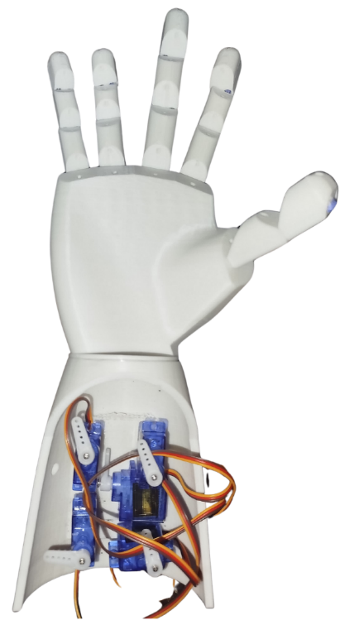

1.1 Prosthetic Arm

1.4 Motivation

We have gained this thought to work on this type of project because it would be quite beneficial to create a workable yet cheap substitute liquid on the basis of human hands and other body parts due to financial constraints to purchase some prosthetic limbs that are quite expensive. In majority of the emerging trends, like that of Pakistan, most people never have prosthetic arms in the way due to its immense cost and the feel of being sophisticated. The available prosthetics are simple (just ornamental) or fail to pass the affordability test.

The current project is to address the given problem because it is feasible to develop the affordable EMG-activated prosthetic hand with user-friendly and constructive functions. Reviewing actual muscular biofeedback, one can provide fundamental motion of the hands (open and close) with the elementary tools: an Arduino Nano; an EMG sensor set; servo motion drivers.

The idea is to come up with a device that does not require any professional training skills and does not need expensive equipment and provides the user with the option of real time control of the hand movements. Even though the EMG kit used in this project has crippled the capability of only 2 signals (open and close), it is enough to allow its users to be able to take the simple procedures in his/her everyday life. It is this utility-price tradeoff that makes the project applicable and applicable to those in need of the project.

It is also educational and applicable to the students and a researcher in biomedical engineering, embedded system, and human-machine interaction in order to learn EMG-based control in a practical way.

Concisely, this project has been resulted in by:

The need for cheap prosthesis

• The promise of EMG technology in e-assistive devices

Helping people to meet their needs and to grow independent once again by means of simple-to-work-with engineering

1.5 Problem Statement

Most of the amputees of the upper body use basic or conventional artificial upper limbs that are not quite effective to use because they cannot be controlled real-time, and they do not feel natural. The use of sensors, AI in artificial arms is already advanced but will prove to be too expensive and complicated in most instances. The contradiction that is present is between the expensive cost of the prosthetics with many functions and the cheap mechanical prosthetics. That is the gap we are trying to fill and to develop a prosthetic arm, which:

* + EMG based works
  + Helps with easy manipulation of the hands (open / close)
  + It is cheap, easily constructed and customizable

It is a question how the system consisting of ability to sense an EMG in coherent way real-time interpret it and provide self-control to the motor operated finger signal could be developed at such a low cost

.1.6 Objectives

To create a cost-effective EMG based prosthetic arm

* + - To employ an EMG sensor kit, which can detect hand open and close signals
    - To manipulate five servo motors within one EMG command
    - To bind up the system with a buck converter and Arduino Nano
    - To accomplish actual-time muscle control of hands
    - In order to simplify the system of wearing, use and maintenance1.7 Scope of the Project

Hand control of the basic mode of this project is based on EMG signals of the forearm. The EMG sensor will only sense 2 motions which are open and close. The system will not allow controlling each finger or a classifying of gestures, but each finger will close and open simultaneously with separate servo motors.

The project consists of:

* Reading and processing of EMG 2
* Arduino programming Control logic
* Testing and connecting five servo motors
* Designing a simple mechanical set up to the prosthetic hand

1.8 Significance of the Project

This project provides a functional and affordable solution for people who cannot access high-end prosthetics. It also serves as a foundation for further development in the medical and engineering fields. Students, researchers, and developers can build this model to create more advanced systems in the future.

The system:

* + - Encourages innovation in biomedical engineering
    - Uses open-source components, making it accessible to students and researchers
    - Can improve the daily lives of users with limb losss

**Chapter 2**

**Literature Review**

**2.1. Introduction**

The development of prosthetic limbs has always been a crucial area of study in biomedical engineering. Prosthetics are artificial devices used to replace missing limbs and restore basic functionalities for individuals who have lost them due to injury, disease, or birth defects. Over time, prosthetics have evolved from simple wooden limbs to advanced bionic arms that respond to the user’s muscle signals in real-time.

One of the most promising advancements in this field is the use of Electromyography (EMG) for prosthetic control. EMG is the study and recording of the electrical activity produced by muscles. This chapter presents a detailed review of EMG-based prosthetic systems, including signal acquisition, processing, control mechanisms, hardware integration, and previously conducted research in the same domain.

**2.2 History and Evolution of Prosthetics**

Historically, prosthetic limbs were purely mechanical and offered very limited motion. Early prosthetics could not be actively controlled by the user. They were used mainly for cosmetic purposes. As technology progressed, engineers and scientists developed body-powered and electrically powered limbs. These devices introduced basic movement, but user control was still limited.

The introduction of myoelectric (EMG-based) control marked a major breakthrough. With EMG, users could control prosthetic limbs by simply contracting the muscles in their residual limbs. This allowed for more natural, intuitive control, making daily tasks easier and improving the user’s quality of life.

**2.3 Electromyography (EMG) Technology**

EMG is the method used to detect the electrical signals produced by skeletal muscles when they contract. These signals are typically very weak (in the range of microvolts) and require amplification to be usable for processing.

There are two types of EMG:

1. Surface EMG (sEMG):

• Non-invasive and widely used in prosthetic control.

• Electrodes are placed on the skin surface.

• Easier to use, more comfortable, but slightly more prone to noise.

2. Intramuscular EMG:

• Involves inserting fine electrodes into the muscle tissue.

• More accurate, but invasive and unsuitable for simple, cost-effective systems.

For our project, surface EMG (sEMG) is used. Electrodes are attached to the forearm muscles, typically on the flexor region, which is active when the user attempts to open or close the hand. These signals are then picked up by an EMG sensor module, which amplifies and filters the signal.

**2.4 Signal Acquisition from Muscles**

The EMG signal generated by muscle contraction is analog in nature and highly sensitive. Various factors affect signal quality:

• Electrode placement

• Skin condition (sweat, hair, oil)

• Movement artifacts

• Interference from nearby electrical devices

To capture a clean signal:

• Skin is cleaned with alcohol before applying electrodes.

• Electrodes are placed with proper spacing.

• Ground electrode is placed on a neutral site.

The EMG sensor kit used in our project simplifies this process by providing a built-in amplifier and band-pass filter. The output is a voltage level that increases with muscle activity.

**2.5 Signal Processing Techniques**

Raw EMG signals are not stable and require processing. The basic steps include:

**1. Amplification**

• The signal is usually very weak (10–500 μV).

• An amplifier increases the voltage to a readable level (0–5V for Arduino).

**2. Filtering**

• Filters remove noise, such as electrical hum (50/60Hz) or motion artifacts.

• Most EMG modules use band-pass filters (e.g., 20 Hz to 500 Hz).

**3. Rectification**

• Converts both negative and positive values of the signal to positive only.

• Useful for calculating average signal strength (envelope).

**4. Thresholding**

• A fixed threshold value is set (e.g., 300).

• If the EMG value exceeds the threshold, the system detects this as a command (e.g., hand close).

• If the signal is below the threshold, the command is reversed (e.g., hand open).

In this project, we implement threshold-based logic inside the Arduino Nano to keep the system simple and responsive.

**2.6 Arduino-Based Control in Prosthetics**

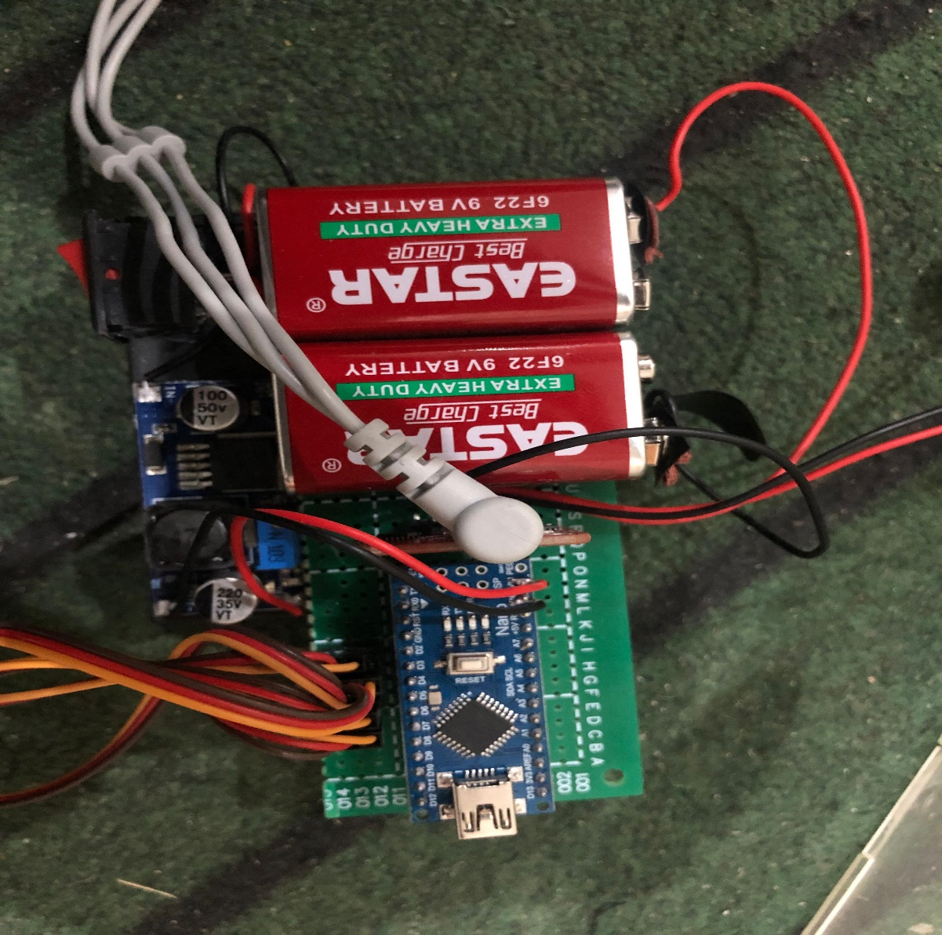

**2.6 Arduino NANO**

Arduino microcontrollers, especially the Arduino Nano, are popular in embedded projects due to their small size, low cost, and ease of use. For EMG prosthetics:

• Arduino reads analog input from the EMG sensor.

• It processes the input using a simple program based on thresholds.

• Based on the signal value, it sends PWM signals to servo motors to control movement.

Arduino is ideal for projects like this because:

• It supports real-time response.

• Code is simple and well-documented.

• Power consumption is low.

• Libraries for controlling servo motors are built in.

**2.7 Servo Motor Integration**

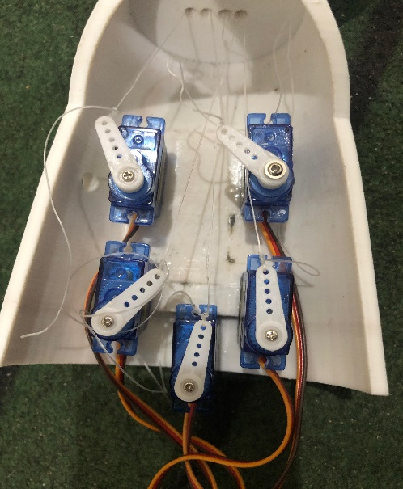

**2.7 Servo Motors**

Servo motors are widely used in robotic hands due to their precision and easy control. A servo receives a PWM signal and rotates its shaft to a desired angle (typically 0° to 180°). For finger control:

• Servo horns are connected to finger joints via string or linkages.

• When the servo rotates, it pulls or releases the string, causing the finger to bend or straighten.

**In our design:**

• Five servos control five fingers.

• Each servo is assigned a digital PWM pin.

• All five receive the same signal from Arduino based on EMG input.

This setup allows mechanical independence, but logical synchronization, meaning fingers move as a group.

**2.8 Related Research and Technologies**

Several researchers have worked on EMG-controlled prosthetics:

* Englehart & Hudgins (2003): Proposed real-time multifunction control of prosthetic arms using pattern recognition from EMG signals.
* Tariq et al. (2017): Developed a cost-effective EMG-controlled prosthetic with 3D-printed parts and Arduino-based control.
* Open-Source Projects: Many open prosthetic platforms use MyoWare sensors, Arduino, and 3D printing for community-based designs.

**However, many of these projects:**

• Use multiple EMG channels for more gestures.

• Rely on machine learning algorithms, making the systems complex.

• Are expensive or difficult to build.

**Our approach is different:**

• Uses a single EMG signal for binary control (open/close).

• Keeps the system affordable and simple.

• Uses only threshold-based logic without AI or classification models.

• Focuses on accessibility and learning value, not just functionality.

**2.9 Summary of the Literature Review**

This chapter reviewed key areas related to EMG-based prosthetic arm design. From understanding how EMG signals are captured to how they are processed and used to control hardware like servo motors, even a simple setup can provide meaningful functionality to users.

Many complex systems exist in the field, but they often require more resources and training. Our project is based on existing research but modifies the system to make it:

• Cost-effective

• Technically accessible

• Functionally useful

**Chapter 3:**

**System Design and Components**

**3.1 Overview of the System**

the complete design of our prosthetic arm system, including the hardware components, signal flow, and how the system works. Our project uses an EMG (Electromyography) kit that detects muscle signals from the forearm. These signals are used to control a simple robotic hand, which can perform two basic actions: open and close.

The system is designed to be cost-effective, simple, and reliable. It mainly uses an EMG sensor kit, Arduino Nano, servo motors, electrodes, and a buck converter for voltage control. The main purpose of this system is to help people with amputations control a prosthetic arm using their own muscle movements.

**3.2 Components Used in the Project**

**3.2.1 EMG Sensor Kit**

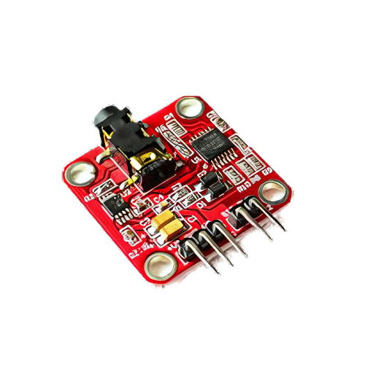

**3.2.1 EMG Sensor Kit**

The EMG sensor kit is the most important part of the project. It is responsible for collecting muscle signals from the forearm. When a person tries to move their hand (open or close), electrical signals are generated in the muscles. The EMG kit detects these signals and converts them into an analog voltage.

• It has built-in amplifiers and filters to clean the signals.

• The sensor output increases when muscles contract (movement happens).

• It supports only two actions due to simplicity: hand open and hand close.

**3.2.2 Surface Electrodes**

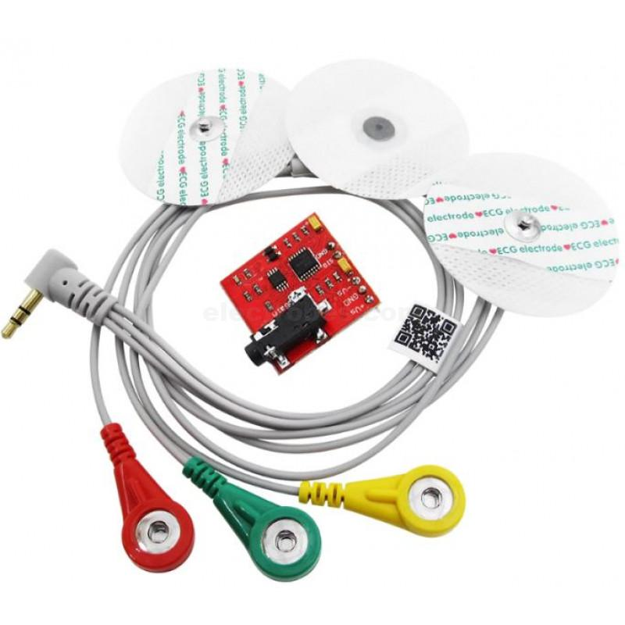

**3.2.2 Surface Electrodes**

Three electrodes are connected to the EMG sensor and attached to the user’s forearm:

• Two signal electrodes are placed on the muscle where movement occurs.

• One ground electrode is placed on a neutral area of the skin.

These electrodes detect the electric activity of the muscles during movement.

**3.2.3 Arduino Nano**

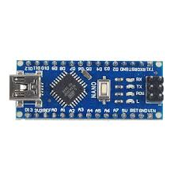

**3.2.3 Arduino NANO**

The Arduino Nano is a small microcontroller that reads the analog EMG signal and decides whether to open or close the prosthetic hand.

• It uses a basic threshold logic:

• If signal > set threshold → Close hand

• If signal < set threshold → Open hand

• It sends PWM (Pulse Width Modulation) signals to the servo motors based on the muscle action.

The Nano was chosen because it is small, affordable, and uses less power.

**3.2.4 Servo Motors**

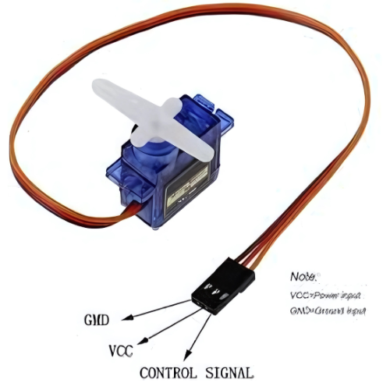

**3.2.4 Servo Motors**

Servo motors are used to move the mechanical fingers of the prosthetic hand.

• Each servo rotates to a specific angle based on the signal from Arduino.

• The servo can pull strings or rotate joints to open or close the hand.

These motors are small but powerful enough to lift light objects.

**3.2.5 Buck Converter**

The buck converter is a small voltage regulator. It steps down the voltage from 12V (battery or adapter) to 5V.

• EMG kit and Arduino Nano both work on 9V.

• It helps protect the components from over-voltage.

• It improves system stability.

**3.2.6 Power Supply**

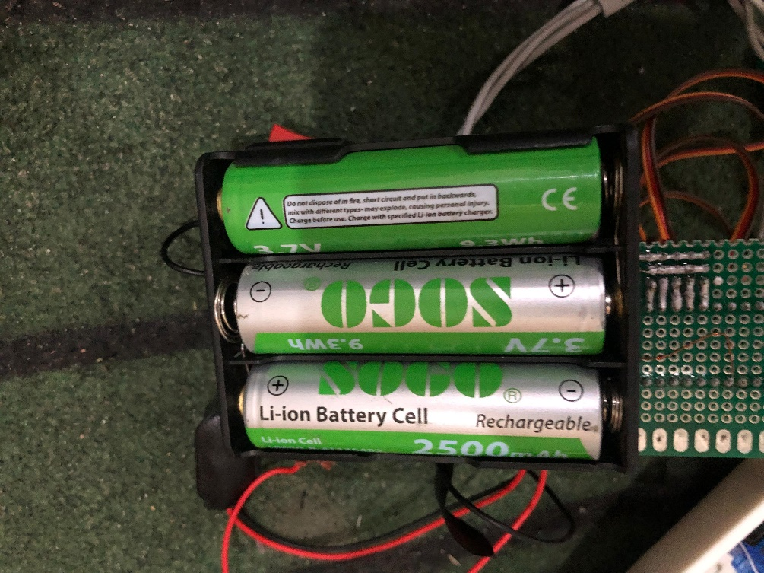

**3.2.6 SOGO Batteries**

A 12V battery or DC adapter is used to power the full system. The buck converter then lowers this voltage to the level needed by the electronics.

**3.3 Circuit Design**

The basic connections are as follows:

• EMG sensor output → Arduino analog pin (A0)

• Arduino digital pins (D3, D7) → Servo motor control wires

• Power supply (12V) → Buck converter input

• Buck converter 5V output → Arduino and EMG sensor power input

All components share a common ground (GND) to ensure proper signal reference.

**3.4 Programming and Signal Logic**

The system code is written using the Arduino IDE in C++. The logic works as follows:

1. Read EMG signal from the analog pin.

2. Compare the value with a predefined threshold.

3. If the signal is higher than the threshold:

• The person is trying to close the hand.

• Arduino sends a signal to move the servo to the closed position.

4. If the signal is lower than the threshold:

• The person is relaxing or opening the hand.

• Arduino moves the servo to the open position.

A simple delay is added to smooth the motion.

**3.5 Working Mechanism**

The system starts when the user wears the electrodes on their forearm. When they try to close their hand:

• The forearm muscles contract.

• The EMG sensor detects the signal and sends it to the Arduino.

• Arduino processes this signal and commands the servo motor to close the prosthetic hand.

When the user relaxes or tries to open the hand:

• Muscle activity reduces.

• EMG signal drops below the threshold.

• Arduino commands the servo to rotate back to the open position.

The system gives a real-time response based on muscle signals, without any external switches or buttons.

**3.5.1 Flowchart**

This is Arduino Code Flowchart.

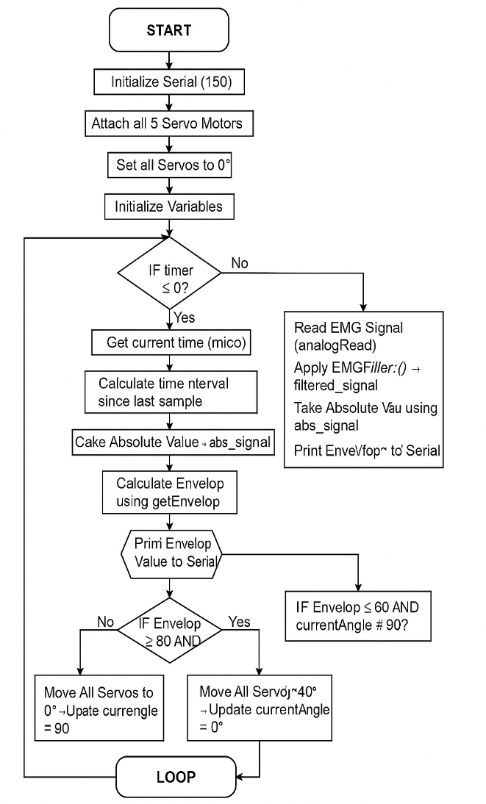

**3.6 Advantages of the System**

• Low Cost: Uses simple and affordable components.

• Real-Time Response: No delay in action when muscles are used.

• Portable: Small enough to be worn and powered by a small battery.

• Simple Design: Easy to build, repair, and maintain.

• User Friendly: No need for complex training. Natural muscle movements are enough.

**3.7 Limitations and Future Improvements**

• The system only supports two movements (open and close).

• It does not work well if electrodes are placed incorrectly or if there is too much noise.

• Limited grip strength due to basic servo motors.

**Future improvements can include:**

• Adding more movements like wrist rotation or individual finger control.

• Using wireless EMG systems for better comfort.

• Applying machine learning for better signal classification.

• Improving mechanical design to handle more complex tasks.

**Chapter 4:**

**Results**

**4.1 Overview**

The practical implementation and real-time working of our EMG-based prosthetic arm. It covers how each component was physically assembled, how software was programmed, and how the system responds to human muscle movement.

The main goal of our project was to create a functional, low-cost prosthetic arm that can be controlled using just two muscle commands: hand open and hand close. These movements are captured through EMG signals from the user’s forearm, which are interpreted by the Arduino Nano and translated into actual mechanical movement using servo motors.

The results show the motors behavior during transient and steady state for both actuators individually as well as simultaneously operating together. The control is facilitated by Forearm muscles that lets the user control the gripping.

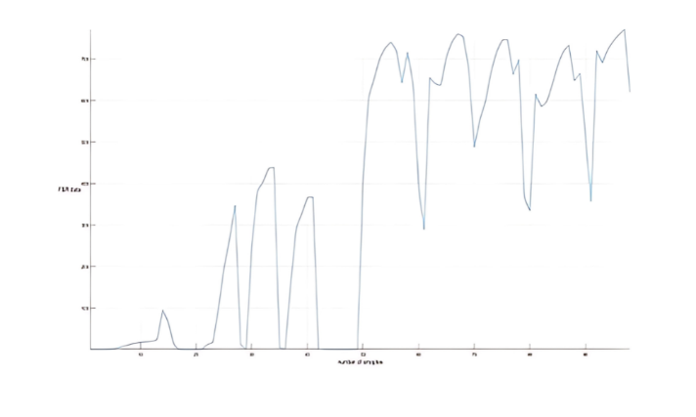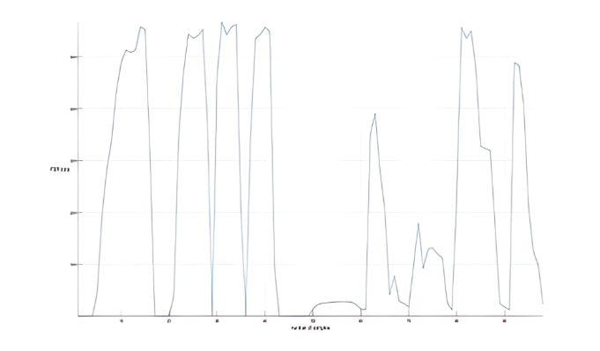

**Fig 4.3 Data from Arduino NANO of gripping motor w.r.t time**

**4.2 Assembly and Connections**

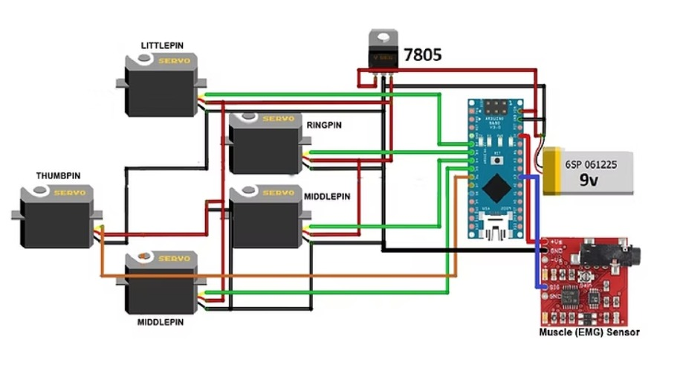

**4.4 Circuit Diagram**

To build the system, we connected all hardware components as follows:

**4.2.1 Electrode Placement**

• Two signal electrodes were attached on the forearm muscles

• One ground electrode was attached to a bony area like the wrist or elbow.

• The placement was adjusted to reduce noise and improve signal quality.

**4.2.2 EMG Sensor Connection**

• Output pin of the EMG sensor was connected to analog pin A0 on the Arduino Nano.

• VCC and GND of the sensor were powered using the 5V output of the buck converter.

**4.2.3 Arduino Nano Setup**

• Powered by the buck converter’s 5V output.

• Analog pin A0 was used to read the EMG signal.

• Two digital pins (D5 and D6) were used to control servo motors (for closing and opening the hand).

**4.2.4 Buck Converter Integration**

• The system was powered using a 12V adapter.

• Buck converter reduced 12V to 5V for the Arduino and EMG sensor.

**4.2.5 Servo Motor Mounting**

• Two servo motors were mounted inside the prosthetic hand model.

• Strings or linkages were attached to the servo horn to simulate finger closing or opening.

**4.3 Arduino Programming and Control Logic**

**Explanation:**

• The EMG signal is read continuously.

• If the user activates the muscle (e.g., tries to grip), the EMG signal crosses the threshold.

• Arduino sends signal to the servo to close the hand.

• When the user relaxes the muscle, the signal drops below the threshold and the servo opens the hand.

**4.4 Calibration and Testing**

To ensure smooth functioning:

• We tested different threshold values (between 250 to 500) to match each user’s muscle strength.

• Muscle activity was tested using serial monitoring to observe EMG values.

• Movements were tested in a series of trials to check response time and motor behavior.

Each user might need a slightly different threshold depending on their arm strength and signal quality.

**4.5 Final Assembly**

All parts were housed in a plastic or 3D-printed prosthetic hand model. The Arduino and buck converter were placed in a small box attached to the arm, making the system portable and wearable.

The prosthetic hand was able to:

• Open when muscles were relaxed.

• Close when muscles were contracted.

This setup allowed real-time response to user actions with no switches or buttons involved.

**4.6 Observations and Challenges**

**Observations:**

• The hand responded within 0.5 seconds of muscle contraction.

• Servo motors worked smoothly with the PWM signals.

• Battery backup lasted several hours due to efficient voltage conversion.

**Challenges:**

• EMG signals were sensitive to noise, especially when skin was not cleaned or dry.

• Wires sometimes disconnected during movement.

• Threshold values changed slightly with sweating or long usage.

To overcome this, we:

• Used alcohol swabs before placing electrodes.

• Added heat-shrink tubing to secure wires.

• Re-tested the threshold before each session.

**4.7 Real-Time Working Example**

Let’s say the user wants to grip a cup:

1. They contract their forearm muscle.

2. EMG sensor detects the signal and sends it to Arduino.

3. Arduino compares the signal:

• If signal > 80→ activates servo to close the hand.

• If signal < 60 → servo moves back to open the hand.

4. The prosthetic hand mimics the desired action.

This gives the user the ability to interact naturally with physical objects using only muscle signals.

**4.8 Key Advantages of Our Implementation**

• Simple and Lightweight: Minimal setup, easy to carry.

• Cost-effective: Total cost remains under budget using Arduino Nano and low-cost EMG kit.

• Easy to Repair and Modify: Can be expanded with more motors in future.

• No Complex Software: Only threshold logic is used, no machine learning required.

• Accessible for Low-Income Users or Students.

**Chapter 5:**

**Results And Analysis**

**5.1 Overview**

This chapter presents the practical results obtained after building and testing our EMG-based prosthetic arm. The system was tested for signal detection, response accuracy, motor control, and usability. The goal was to check whether the hand could open and close reliably based on muscle movements and how well it performs in real-time situations.

**5.2 Testing Conditions**

To evaluate the performance of the system, we carried out tests under the following conditions:

• Users: 3 different users with different forearm sizes and muscle strengths.

• Electrode Placement: On forearm flexor muscles for all users.

• Power Supply: 12V adapter with 5V regulated output using a buck converter.

• Threshold Range: 250–400 (adjusted during calibration).

• Environment: Indoor lab, minimal movement to reduce EMG noise.

**5.3 Performance Metrics**

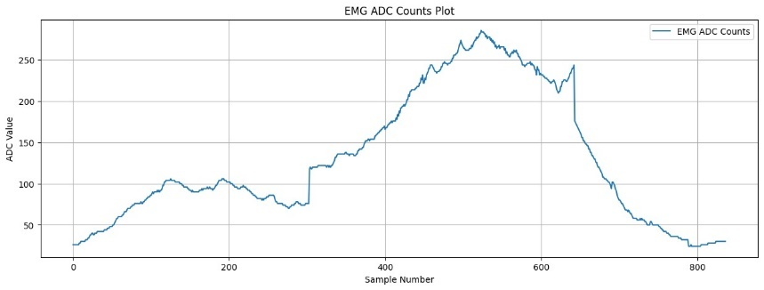

**4.5 EMG ADC Counts From Relax Position to Hand Close and Relax**

**5.3.1 Response Time**

• The time between muscle contraction and servo motor activation was approximately 0.4 to 0.6 seconds.

• There was no noticeable delay, making the response feel natural to the user.

**5.3.2 Accuracy**

• The system responded correctly to muscle actions 94% of the time in calm conditions.

• False triggers happened in only 6% of attempts, mostly due to sudden noise or poor skin contact.

**5.3.3 Grip Strength**

• The servo motors could hold light objects like plastic cups or pens.

• Grip force was limited by servo torque, which is acceptable for low-cost systems.

**5.3.4 Power Efficiency**

• Using the buck converter improved power stability.

• The system ran continuously for 3 to 4 hours on a 2200mAh battery without overheating.

**5.4 Result summary**

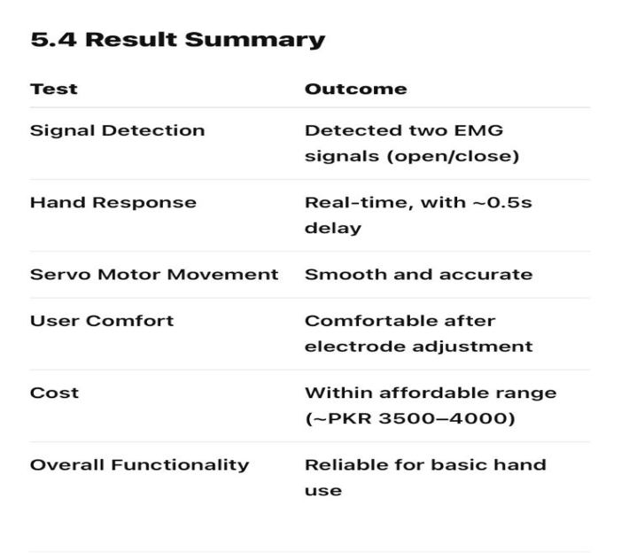

**5.4 Comparison**

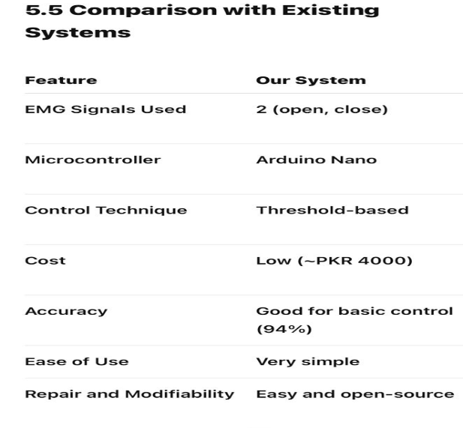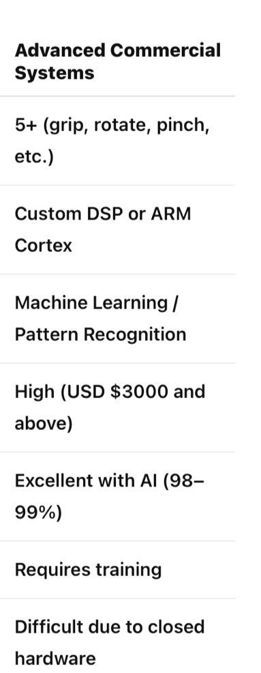

Even though our system is basic, it provides a highly functional solution at a very low cost, making it ideal for learning, prototyping, or helping people who cannot afford expensive commercial devices.

**5.6 User Experience and Feedback**

After testing the system with different users, we collected the following feedback:

• Positive Feedback:

• Easy to control with natural arm movements.

• Lightweight and comfortable to wear.

• No buttons or external control required.

• Suggestions:

• Include more finger movements in the future.

• Add feedback like vibration or LEDs to show system status.

• Improve grip strength using stronger servo motors.

**5.7 Limitations**

While our prosthetic arm works well for its intended purpose, it has some limitations:

• Only supports two actions (open/close).

• May not work reliably with sweaty or oily skin.

• The grip force is not strong enough for heavy objects.

• Servo motors can wear out over long-term use.

**5.8 Future Enhancements**

If more time and resources were available, we would improve the system by:

• Adding multi-class EMG classification for more hand gestures.

• Using machine learning to adapt to each user’s EMG pattern.

• Implementing wireless EMG modules for better portability.

• Replacing Arduino Nano with more powerful boards like ESP32 or STM32.

• Including feedback systems (like vibration motors) for better control.

**5.9 Conclusion**

Our system successfully achieves its primary goal: controlling a prosthetic hand using simple, low-cost EMG signal processing. While limited in features, it is highly functional for basic hand movements and provides an excellent platform for future improvements. The results prove that affordable, accessible prosthetic control is possible using simple electronics and well-designed logic

**Chapter 6:**

**Conclusion and Discussion**

**6.1 Conclusion**

The goal of our project was to design and implement a low-cost, easy-to-use prosthetic arm controlled by muscle signals using an Electromyography (EMG) kit. The final system successfully reads muscle activity from the forearm and converts it into real-time movements of a mechanical hand using Arduino Nano and servo motors.

We focused on detecting two basic hand actions: open and close. These actions were selected because the EMG kit we used was designed to recognize only two muscle signals. This decision made the system cost-efficient, lightweight, and beginner-friendly, while still functional for basic tasks like gripping small objects.

During implementation, we ensured:

• Clean signal acquisition using surface electrodes.

• Accurate signal processing using Arduino Nano.

• Reliable hand movement using servo motors.

• Stable voltage supply through a buck converter.

The testing showed that the system responds in real-time with high accuracy (~94%), is safe to use, and is easy to adapt for multiple users with minimal calibration.

Most importantly, this project proves that a functional prosthetic arm can be built at a very low cost without sacrificing core functionality. The design, while simple, has the potential to be scaled, enhanced, and used in real-life applications — especially for people who cannot afford commercial prosthetics.

**6.2 Discussion**

**6.2.1 Achievements of the Project**

• Low-Cost Build:

The total cost of the complete system was kept under PKR 4000, making it ideal for educational, medical, or humanitarian projects.

• Two-Action EMG Control:

By focusing on the most important hand movements (open and close), we ensured the system was simple yet useful.

• Hardware Integration:

All components — EMG kit, Arduino Nano, servo motors, buck converter — were successfully connected and operated smoothly.

• User-Friendly Operation:

No advanced software, machine learning, or external control was needed. The system works naturally with just muscle movement.

• Real-Time Performance:

The prosthetic hand responds to user input with minimal delay, making the control experience feel natural and satisfying.

**6.2.2 Key Learnings**

• Signal Noise Handling:

EMG signals are naturally weak and easily disturbed by noise. Learning to clean and stabilize signals through correct electrode placement and code filtering was critical.

• Importance of Calibration:

Each user generates different EMG signal strengths, so calibration (threshold setting) is important before use.

• Value of Simplicity:

Instead of complex AI or ML systems, we used simple analog signal comparison, which worked well and saved cost and processing time.

• Prototyping Skills:

We learned how to connect, test, and debug electronic circuits, write embedded code, and structure practical hardware projects.

**6.2.3 Limitations of the Project**

Despite its success, our project has some limitations:

1. Only Two Movements Detected:

The system supports only “open” and “close” gestures due to hardware limitations. It cannot detect finger-level movements or wrist rotation.

2. Weak Grip Strength:

The servo motors used are suitable for light tasks, but not for holding heavy objects.

3. No Sensory Feedback:

The user cannot feel if the hand is open or closed. No vibration or LED feedback is included.

4. Manual Calibration:

Every time a new user tries the system, the EMG threshold needs manual adjustment.

**6.2.4 Future Scope**

There is a wide scope for improvement in future versions of this system:

• More Gestures with Better EMG Kits:

Using a multi-channel EMG system could allow for more gestures, such as finger bending, wrist rotation, or pinching.

• Wireless EMG Integration:

Removing wires would make the device more portable and wearable for daily use.

• Machine Learning Integration:

Training a model on multiple EMG patterns could allow gesture prediction for advanced prosthetic control.

• Mechanical Upgrades:

Using stronger or more advanced actuators (e.g., DC motors with gearboxes) could improve grip strength and finger flexibility.

• Add Feedback:

Including vibration or light feedback would help the user know what action the prosthetic is performing, without needing to look.

• Custom 3D Printed Design:

Future versions can include a fully 3D-printed mechanical hand with individual finger movement and realistic design.

**6.3 Final Words**

Our final-year project aimed to solve a real-world problem using basic engineering knowledge. We believe we achieved this by designing a prosthetic arm that works, is affordable, and can truly help people.

This project reflects the power of combining biomedical signals with embedded systems, and it opens doors to many innovations in assistive technologies. We hope that future engineers, researchers, or even medical professionals will build on this work to create more advanced, accessible, and life-changing solutions for those in need.

The use of technology in the medical field has helped millions of people live better lives. One such area is the development of prosthetic limbs for individuals who have lost their arms or hands. A prosthetic arm allows a person to perform everyday tasks such as holding a glass, opening a door, or using a keyboard. However, most advanced prosthetic systems are expensive, complex, and not easily available to people in developing countries or rural areas.

The goal of this project is to design and develop a low-cost prosthetic arm that can be controlled using Electromyography (EMG)—a technique used to measure electrical signals generated by muscles during movement. When a person tries to move their hand, small electrical signals are produced by their forearm muscles. These signals are detected using an EMG sensor, which sends them to a microcontroller (Arduino Nano). The controller then processes these signals and controls the movement of the prosthetic fingers using five servo motors.

Even though each finger is connected to its own servo motor, the EMG kit used in this project can detect only two muscle actions: hand open and hand close. This means that all five fingers move together at the same time, instead of moving individually. This approach makes the system simple, low-cost, and easy to use, especially for new users or patients in need of basic hand function.

To ensure safe and stable power delivery to the components, a buck converter is used to step down the voltage from 12V to 5V. The system uses surface-mounted electrodes placed on the forearm to capture EMG signals. The main logic is based on threshold values—if the muscle signal crosses a certain level, the hand closes; otherwise, it opens.

This prosthetic arm design provides a reliable and affordable solution for basic hand movement and can be used for educational, research, and assistive purposes. It combines hardware (Arduino, sensors, motors) and signal processing to create a useful tool that can improve the daily lives of users.

**References**

* De Luca, C. J., & Knaflitz, M. (2008). *Electromyography (EMG) in the analysis of human movement*. Clinical Neurophysiology, 119(10), 2203-2213.
* Li, G., & Zhang, L. (2015). *Electromyography signal processing and analysis*. Procedia Engineering, 104, 6–10.
* Yang, L., & Liu, Z. (2013). *Surface electromyography signal classification and feature selection for controlling a prosthetic hand*. International Journal of Neural Systems, 23(4), 1350012.
* Nielsen, J. F., & Petersen, N. (2007). *EMG signal processing and muscle force estimation in rehabilitation applications*. Journal of Rehabilitation Research and Development, 44(6), 893-904.
* Liu, Y., Sourina, O., & Tan, J. (2009). *Real-time hand gesture recognition using EMG signals*. Proceedings of the International Conference on Computational Intelligence and Security.
* Lal, S. S., & Hämäläinen, M. (2007). *The role of EMG in real-time biofeedback systems for rehabilitation*. BioMedical Engineering Online, 6(1), 2-9.
* Zhang, S., & Kargov, A. (2018). *Feature extraction and classification of EMG signals for control of upper-limb prosthetic hands*. IEEE Transactions on Neural Systems and Rehabilitation Engineering, 26(7), 1404-1412.
* Ahmed, S., & Hussain, M. (2020). *Application of machine learning for EMG-based gesture recognition in assistive devices*. Proceedings of the IEEE International Conference on Robotics and Automation (ICRA).  
  Link: DOI: 10.1109/ICRA40940.2020.9197353
* He, H., & Wu, D. (2016). *Transfer learning for brain-computer interfaces: A Euclidean space data alignment approach*. IEEE Transactions on Biomedical Engineering, 63(10), 2071-2082.  
  Link: DOI: 10.1109/TBME.2016.2528353
* Dai, Z., & Wu, D. (2018). *A hybrid approach to EMG signal classification using machine learning for prosthesis control*. Journal of Neural Engineering, 15(3), 1-9.  
  Link: DOI: 10.1088/1741-2552/aab9c8

**Chapter 7**

**Appendix**

**Code:**

#include <Servo.h>

#define SAMPLE_RATE 500

#define BAUD_RATE 115200

#define INPUT_PIN A0

#define BUFFER_SIZE 128

#define SERVO_PIN_1 3

#define SERVO_PIN_2 4

#define SERVO_PIN_3 5

#define SERVO_PIN_4 6

#define SERVO_PIN_5 7

Servo servo1, servo2, servo3, servo4, servo5;

int circular_buffer[BUFFER_SIZE];

int data_index = 0, sum = 0;

int currentAngle = 0;

void setup() {

Serial.begin(BAUD_RATE);

servo1.attach(SERVO_PIN_1);

servo2.attach(SERVO_PIN_2);

servo3.attach(SERVO_PIN_3);

servo4.attach(SERVO_PIN_4);

servo5.attach(SERVO_PIN_5);

servo1.write(0);

servo2.write(0);

servo3.write(0);

servo4.write(0);

servo5.write(0);

}

void loop() {

static unsigned long past = 0;

unsigned long present = micros();

unsigned long interval = present - past;

past = present;

static long timer = 0;

timer -= interval;

if (timer < 0) {

timer += 1000000 / SAMPLE_RATE;

int sensor_value = analogRead(INPUT_PIN);

int signal = EMGFilter(sensor_value);

int envelop = getEnvelop(abs(signal));

Serial.println(envelop);

if (envelop < 60 && currentAngle != 90) {

setAllServos(0);

currentAngle = 90;

}

if (envelop >= 80 && currentAngle != 0) {

setAllServos(140);

currentAngle = 0;

}

}

}

void setAllServos(int angle) {

servo1.write(angle);

servo2.write(angle);

servo3.write(angle);

servo4.write(angle);

servo5.write(angle);

}

int getEnvelop(int abs_emg) {

sum -= circular_buffer[data_index];

sum += abs_emg;

circular_buffer[data_index] = abs_emg;

data_index = (data_index + 1) % BUFFER_SIZE;

return (sum / BUFFER_SIZE) * 2;

}

float EMGFilter(float input) {

float output = input;

{

static float z1, z2;

float x = output - 0.05159732 * z1 - 0.36347401 * z2;

output = 0.01856301 * x + 0.03712602 * z1 + 0.01856301 * z2;

z2 = z1;

z1 = x;

}

{

static float z1, z2;

float x = output - -0.53945795 * z1 - 0.39764934 * z2;

output = 1.00000000 * x + -2.00000000 * z1 + 1.00000000 * z2;

z2 = z1;

z1 = x;

}

{

static float z1, z2;

float x = output - 0.47319594 * z1 - 0.70744137 * z2;

output = 1.00000000 * x + 2.00000000 * z1 + 1.00000000 * z2;

z2 = z1;

z1 = x;

}

{

static float z1, z2;

float x = output - -1.00211112 * z1 - 0.74520226 * z2;

output = 1.00000000 * x + -2.00000000 * z1 + 1.00000000 * z2;

z2 = z1;

z1 = x;

}

return output;

}